Master Finance KB

Document Status: Revised Final Draft
Created On: November 25, 2020
Last Updated: November 04, 2025
Contact: ITG Technical Writers, IT Service Desk Team, Infrastructure EUC Team, Richard Cheng

Contents
1 Purpose 3
2 Scope 3
3 Audience 3
4 Finance Applications 3
4.1 ATO ECI 3
4.1.1 What is an AUSKey? 3
4.1.2 How to Transfer an AUSKey? 4
4.1.2.1 How to Back-up your AUSKey KeyStore? 4
4.1.2.2 How to Restore your AUSKey KeyStore and Movie it to another Computer? 4
4.1.3 AUSKey Help 4
4.2 ARCS2G(1.57D) 5
4.2.1 Installation 5
4.2.2 Establishing Connection to ARCS2G Database 5
4.2.3 Configuring ARCS Outlook Add-In 6
4.2.4 Running ARCS Scheduled Tasks 7
4.3 EDG Software 7
4.4 Elite 8
4.5 LEWIS PAY BACK 8
4.6 Chris21 Payroll Archive 9
4.6.1 Creating a User Account in Chris21 10
4.7 Microsoft Power BI Backup 10
4.8 Xcelerate 10
4.9 Finance EFR 11
4.10 3E Excel Office Add-In 11
5 Additional Information 12
6 Revisions 12
7 Document History 12
8 Document Control Log 12

Purpose
This document’s purpose is to describe the installation procedure of Windows 10 (v 1803) Finance Applications for Airwatch Devices within G+T. It covers details regarding the available finance applications, their utility features, online and offline software packaging locations, installation requisites, data backup, and restore procedures.

Scope
The scope of this guide includes all staff who have or are responsible for Windows 10 (v 1803) Finance Applications for Airwatch Devices (or any form of access that supports or requires this installation) on any system that resides at G+T, has access to the G+T network, or stores any non-public G+T information.

Audience
The section identifies the individuals/teams with a stake in getting the Finance applications configured on their Windows 10 supported Airwatch devices. Below are the collaborators who can actively participate in defining or changing the standard installation and backup procedure of these applications within G+T:
- Service Desk Team
- Infrastructure EUC Team

Finance Applications
The section lists down the on-demand and available finance applications and services, which the SD team requires to set up within their systems for different purposes. For each mentioned application/service, you can view information related to its installation process, requisites, packaging location, URLs to download the software, and more.

ATO ECI
The finance team can access the following location to install the ATO ECI application: \\sydney.gtlaw.com.au\shares\apps\Finance\ATO ECI software

Liz, Nyree, Bambi, and Tim from the Finance team consult with ATO to perform the installation. To do so, they require a digital certificate installed on their PC from ATO called AUSkey, which they can transfer from another computer using the URL: https://abr.gov.au/AUSkey/Managing-AUSkeys/Use-AUSkey-on-another-computer

What is an AUSKey?
AUSKey is a software designed as an alternate, more secure authentication method for businesses and users of Australian Government websites. It is a single key to access online government services. You may no longer need different user IDs and passwords in the future as most of the government agencies will accept AUSkey for their online services.
Advantages
  - Minimize the count of user IDs and passwords you need to maintain.
  - Lodge reports to the Australian Taxation Office (ATO), the Australian Securities & Investments Commission, and all state and territory revenue offices through SBR-enabled business and accounting software.
  - Login to government online services including ATO portals.
  - Lodge on behalf of your clients.
Features
    - Easy online registration: You can use your AUSkey immediately in most cases.
    - Flexible installation options: You can install your AUSkey on your computer, a USB stick, your organization’s server, or a combination of these.
    - Online management facility: You can view and update your details, cancel passwords, and do more.
    - Automatic renewal: Your Auskey never expires until you use it at least once a year.

How to Transfer an AUSKey?
Transferring an AUSkey typically includes:
    - Backing up your AUSkey KeyStore
    - Restoring your AUSkey KeyStore or move it to another computer

How to Back-up your AUSKey KeyStore?
Backing up your AUSKey KeyStore involves the following steps:
Step 1: Create a copy of the AUSkey keystore.xml file in C:\Users\USERNAME\AppData\Roaming\AUSkey.
Step 2: Copy the keystore.xml file to your backup location.
Please Note: When logging into portals, the password used for the current KeyStore will remain the same used for each KeyStore copy so created. In the case of forgetting passwords, there is no way to use a back-up KeyStore to restore an AUSkey. In such a case, you will need to re-register for a new AUSkey.

How to Restore your AUSKey KeyStore and Movie it to another Computer?
To restore your AUSkey KeyStore and move it to another computer, perform the following steps:
Step 1: Install the AUSkey Software on your secondary computer.
Step 2: Visit the URL https://www.auskey.abr.gov.au/install.aspx?pid=71 and download the AUSKey software setup. Install the software on your device.
Step 3: Add the KeyStore to your secondary computer by copying the keystore.xml file from your backup location to the same directory on the computer.
**Warning**: The above procedure replaces any AUSKey present on the destination PC. If you already have an AUSKey installed on the destination PC, please contact the helpdesk for alternative arrangements.

AUSKey Help
For more information and advice, please visit www.auskey.abr.gov.au. To get more help with AUSKey management, click here.
For assistance with a first-time registration, lost email, or forgotten password, please contact: 1300 AUSKEY (1300 287 539) Option 1, Monday – Friday, between 8:00am and 6:00pm
For technical assistance, please contact: 1300 AUSKEY (1300 287 539) Option 2 or +61 2 6211 9306 (international callers only) Monday – Friday, between 7:00 am and midnight.
Please Note: To do AUSKey work with Chrome browser, you may need to enable necessary extensions post-installation. However, Internet Explorer uses Java.

ARCS2G(1.57D)

Installation
You can install this software by adding users to the AD group app.ARCS2G.users and pushing the deployment via Airwatch. Software packaging for Airwatch resides in \\vmfilesharesyd1\soeapps\ARCS2G\v1.57
Finance team can find the same in \\sydney.gtlaw.com.au\ops\elite\ARCS\ARCS2G01.57.14\ARCS2G01.57\Installation Files
Please Note: You need to provide local admin rights to the user if installing the software locally. It is because the Install action writes to the following file, which user may not have access rights to:
C:\Windows\Microsoft.NET\Framework64\v4.0.30319\Config\machine.config (.net location may change depending upon the version installed.) During a first-time installation, this command line enhancement writes an entry to the machine.config file.

Establishing Connection to ARCS2G Database
It is a one-time setup per each client installation. To establish the database connection, perform the steps below:
Step 1: Search for ARCS2G Config icon in Cortana, right-click the icon, and choose the Run as administrator from the context menu.
Step 2: The Find File prompt appears, as shown below. Select the database instance from the list by clicking the button and press OK:
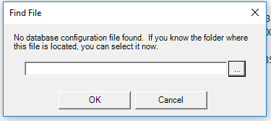

You can locate the database configuration file (DBconfig.dat) in \\sydney.gtlaw.com.au\ops\elite\ARCS\2G_Data\DBConfig.dat. If you do not find the database instance you wish to connect with (ARCS_3E_PROD) in the list, perform step 3.

Step 3: Create a new instance with appropriate credentials:
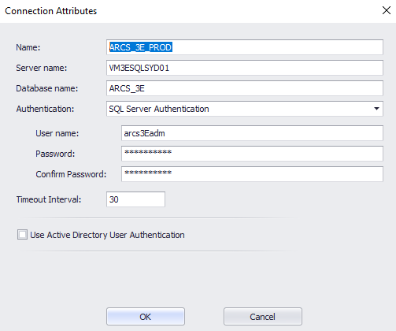

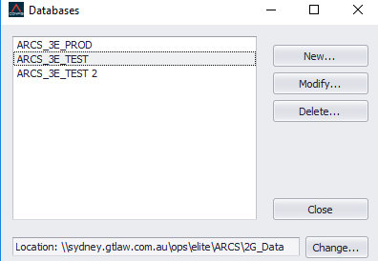

Step 4: Logon to the ARCS2G app (using your credentials) and select the database you want to connect to (e.g., ARCS_3E_PROD).

Configuring ARCS Outlook Add-In
You can install ARCS add-in as a new feature to Outlook (via deployment from Airwatch). The feature enables users to export emails to the ARCS2G database.
You first need to temporarily add the user as a local admin to the AD group, i.e., grp.Admin.Local PC. As an administrator, the user can then configure the ARCS Outlook add-in by following the steps below:
Step 1: Run ARCS_addin.bat located in \\vmsoeappsyd1\apps\ARCS2G\Installation Files\2G Application One Install
Step 2: Check in add/remove programs installed by the add-in, i.e., ARCSOutlookAddin.
Step 3: Run a repair using the NDOffice.
Step 4: Right-click and run the Outlook to configure add-ins by selecting File> Options> Add-Ins > Add-Ins Options:
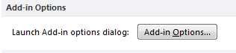

Step 5: On Add-in Options dialog, select ARCS_3E_PROD in the Database drop-down:
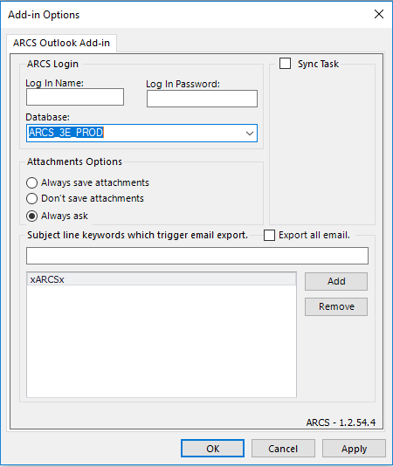

Running ARCS Scheduled Tasks
It involves running the file ARCS2GScheduler.exe on the VMPMSICSYD1 machine and includes running the reporting scheduled tasks.

EDG Software
You can locate the EDG software packaging at \\ntnas\it\Apps\Finance\EDG. Getting the software involves using EPI (Elite Platform Installer) tool to install the Visual Designer.
Next, you need to install the Solution Manager 2.6.5 from the location \\ntnas\it\Apps\Finance\EDG\DesignGallery_2.6.5_WorkstationComponents_x64\x64 and then apply the 2.6.8 hotfix. Installing the hotfix below involves copying and pasting the hotfix file over the Solution Manager files (there are no executables): \\ntnas\it\Apps\Finance\EDG\Design Gallery Solution Manager 2.6.8.0 Hotfix
Solution Manager Installation Problems
While Setting up Solution Manager v2.6.x on your computer, you may encounter certain issues using the application. What can cause such behavior? The operating system flags the archive (containing the setup.exe file) as blocked, causing specific components (referred menu items or entries) to go missing or the assembly errors to show.
Solution(s)
The above problem finds the solutions in six straightforward steps, by which to follow:
Step 1: Uninstall the Solution Manager application.
Step 2: Locate the .zip file (containing the app setup) on your PC, right-click on it and select ‘Properties’ from the context menu.
Step 3: On the dialog box, click Unblock button in the Security section:
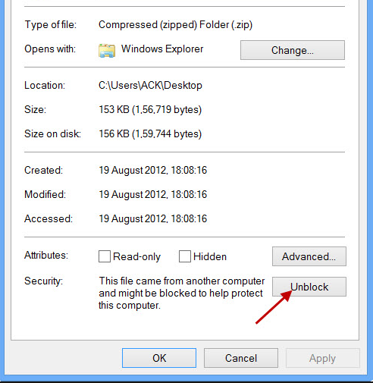

Step 4: Right-click the file again to extract the zip file.
Step 5: Once the extraction finishes, perform steps 2 to 4 (above) on other extracted files to ensure you no longer see the above Security section (Implicates that unblocking the original zip file automatically flags the following unzipped files as unblocked)
Step 6: Re-install the Solution Manager, reboot the machine after installation and check if the issue persists.

Elite
Elite includes accessing 3E, Billing, and Financial Reporting tools. Web-based 3E and Billing software do not require any installation. However, Financial Reporting (EFR) is an Outlook add-in, which requires MS Office. The installation is excel-dependant (Discussed in section 4.9).

LEWIS PAY BACK
G+T used LEWIS PAY BACK before Chris 21 (occasionally referred by Liz Velasco once or twice a year). You can locate the software packaging at \\sydney.gtlaw.com.au\Ops\Finance and directly run the app from this location. All you need is to follow these steps:

Step 1: Run the application by clicking on the pay.exe file on Avecto allowlist:
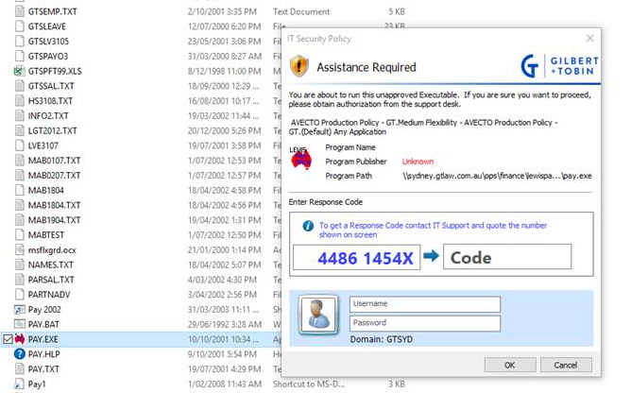

Step 2: Copy the three files, i.e., msflxgrd.ocx, comdlg32.ocx and sysinfo.ocx from \\sydney.gtlaw.com.au\Shares\eucapps\Finance\Lewis PayPack to C:\Windows\SysWOW64.
Step 3: Register these files by running the command prompt with elevated privileges:
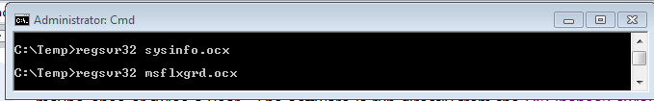

Chris21 Payroll Archive
Chris21, G+T’s payroll system until late 2021, is now a historical archive. The Finance payroll team occasionally manages it.
Issue: If payroll reports that access to chris21 is unavailable, they may encounter the error message below indicating system inaccessibility:
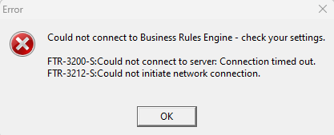

Possible Cause: The BRELauncher service has stopped on VMCHRISSYD1:
Resolution: Follow these steps to restore access:
Step 1: Verify Service Status:
- Navigate to the service management console.
- Locate BRELauncher on VMCHRISSYD1:
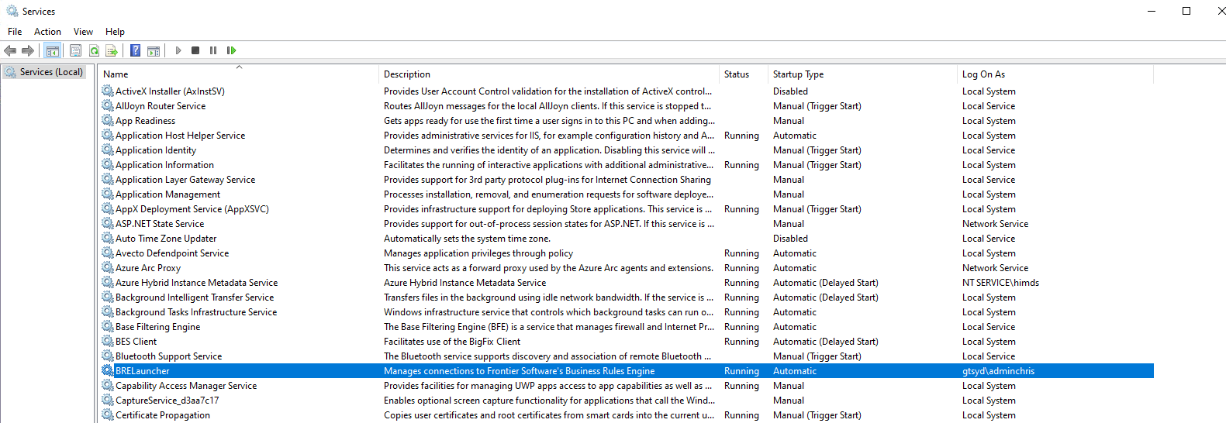
Step 2: Restart the Service:
- Right-click the BRELauncher service and select Restart.
- Please wait for the service to initialize and confirm that it is running.
Step 3: Validate Access:
- Attempt to log in to Chris21.
- Confirm that payroll can retrieve historical records.

Creating a User Account in Chris21
To request a new user account in Chris21, first contact Susie Wyatt. If she is unavailable or unable to assist, email Haydn Cross at haydn.cross@epiqglobal.com.
Please note that Geoff Dowell previously managed this process.

Microsoft Power BI Backup
Only the selected licensed users need the necessary approvals to get Microsoft Power BI Desktop (x64). You can install this software by:
- adding users to the AD group app.PowerBI.users
- automatically pushing the deployment via Airwatch

Xcelerate
You must install the MS Office first as installation of Xcelerate is excel-dependant since it is an Excel add-in. Selected licensed users from the Finance team need the necessary approvals to get this On-Demand app. You can install this software by:
- adding users to the AD group app.Xcelerate.users and Xcelerate security group.
- pushing the deployment via Airwatch.

Finance EFR
Finance EFR is an Excel add-in, so you must install MS Office first as the installation is excel-dependant. Anyone from the Finance team who needs the Financial Reporting must follow the following instructions:
Step 1: Run .msi from \\vm3ebizsyd01\TE_Software\3E Financial Reporting 3.0.1.0\Full Package\Setup AddIn.msi

Step 2: Enter the path to the configuration file as \\vm3ebizsyd01\3EFR_Share\config.xml

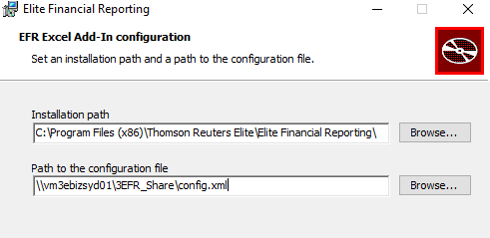

3E Excel Office Add-In
3E Office is an Excel add-in. You must install MS Office first as the app installation is excel-dependant. You can locate the software packaging at the following location: \\sydney.gtlaw.com.au\shares\eucapps\Elite 3E\excel3eintegration2010setup_2.7.0012\
People who own access to this software are Tim Gauci, Nyree, Susie Wyatt, and Bambi.
You can find the Server at http://vm3ewapisyd01/TE_3E_PROD.
show list = 10
show both code/caption
Open Excel once the system finishes the installation. Click on the ‘Install’ button when prompted with the below message dialog:
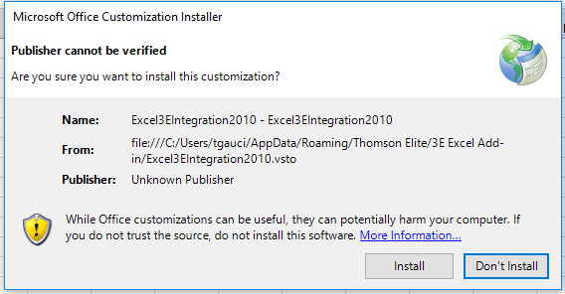

Additional Information
For information on VMWare Applications Volume for Horizon desktop, refer to the App Stack dataà
Drive Mappings for HR and Finance Team
Below are the available drive mapping locations:
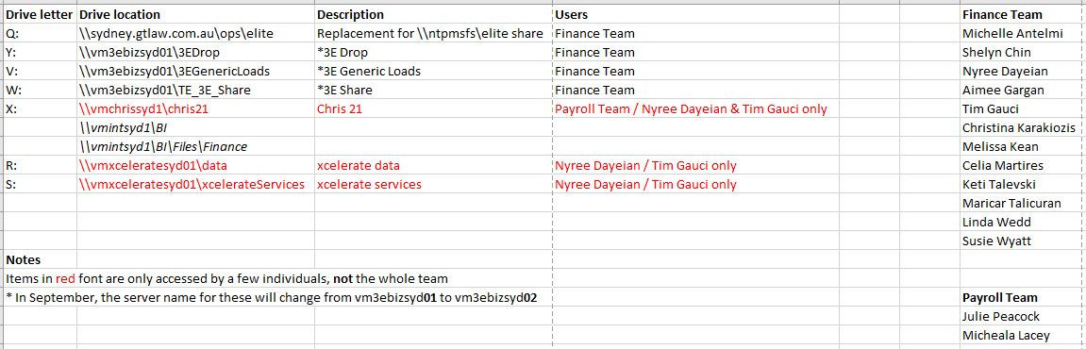

Revisions
The Infrastructure and Technical Writing teams regularly examine, evaluate, and amend this document as risks, systems, and business processes change.

Document History
Title | Master Finance KB
Version | 0.4
Classification | Internal
Creation Date | November 25, 2020
Last Review Date | November 04, 2025
Author | Priya Bhatia
Custodian | Infra EUC, Service Desk
Document ID | 3441-8413-7238

Document Control Log
Version | Change description | Authored by | Reviewed by | Approved by | Date of creation
0.1 | Recreated/Restructured the entire documentation | Priya Bhatia | Richard Cheng | Richard Cheng | November 25, 2020
0.2 | Reformatted the Document as per current template and removed Chris 21 Subsections and updated path in 4.1 and 4.2.1. | Sharmila Grace | Priya Bhatia, Vikram Yadav | Vikram Yadav | June 05, 2023
0.3 | Addes section 4.5.1 chris21 System Unavailability: Troubleshooting and reformatted the document as per standard templates | Suresh Narasimhan | Priya Bhatia | Priya Bhatia | June 05, 2025
0.3 | Reviewed section 4.5.1 and implemented adjustments where necessary | Priya Bhatia | Sergio Pasapera | Sergio Pasapera | June 05, 2025
0.4 | Added section 4.6.1 Creating a User Account in Chris21 | Suresh Narasimhan | Priya Bhatia | Priya Bhatia | November 04, 2025
0.4 | Approved the version with changes | Priya Bhatia | Jye Koperberg | Jye Koperberg | November 04, 2025

